CURY PARISH COUNCIL

I hereby summon you to attend a Meeting of Cury Parish Council to be held at 7.30pm on Wednesday 13 January 2016 in the Cury Methodist Chapel, Cury. The public and press are cordially invited to attend. Any plans are available to view from 7.15pm.

1. Apologies for Absence
2. Declarations of Interest – Members to declare personal and prejudicial interests (including details thereof) in respect of any item(s) on this Agenda
3. Chairman’s Comments
- To agree the Minutes of the Parish Council Meeting held on Wednesday 11 November 2015
5. Matters arising from the above approved minutes which are not covered in this agenda
6. Reports
(a) To receive the Police Report
(b) To receive the Report from Cury School
(c) To receive the Report from Cornwall Councillor W Sanger
(d) Helston and South Kerrier Community Network Panel – Wednesday 2 December 2015
7. Planning
(a) To consider and respond to any Planning Applications received
(i) PA15/10910 – Penvearne Farm – New general agricultural building – Mr & Mrs C Jenkin
(b) To receive any Planning Decisions
(i) PA15/09228 - Mr & Mrs A Stott -2 Parknoweth, Churchtown - Proposed replacement roof covering, conversion of part of loft space to form habitable accommodation and construction of a dormer window extension - Approved
(c) Paperless Planning update
(d) To receive any further planning correspondence
8. Parish Matters
To consider the following:-
(a) Playing Field
(b) Highways
(c) Public Rights of Way
(d) Public Open Spaces (Cemetery, village green, etc)
(e) Emergency Plan
9. Financial Matters
(a) To set the Precept Demand for 2016/17
(b) To receive and approve the financial report for the previous two months
(c) To receive any LGA 1972 Section 137 Requests for grant funding
(d) Other matters
10. Correspondence
11. Matters for the next Parish Council Meeting
To receive notice of items to be included on the agenda for the next Parish Council Meeting scheduled to be held on Wednesday 09 March 2016 in the Cury Methodist Chapel

Council to withdraw if necessary under the Public Bodies Admissions to Meetings Act 1960 Section 1, Local Government Act 1972 Section 100 Sections 2 & 3 and Local Government Act 172 Schedule 12 Section 42. Given under my hand this Fifth day of January 2016.

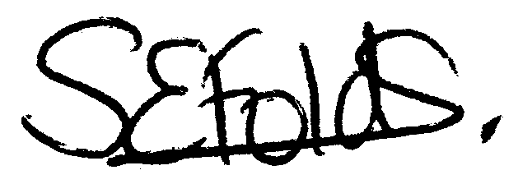

Samantha Folds - Clerk to Cury Parish Council

