CURY PARISH COUNCIL

I hereby summon you to attend a Meeting of Cury Parish Council to be held immediately following the Annual Meeting of Cury on Wednesday 08 July 2020 remotely - online or by telephone via Microsoft Teams. The public and press are cordially invited to attend. Joining instructions are available by emailing the Clerk on curypc@btinternet.com or by calling 01326 572065.

1. To approve the Amendments to the Standing Orders under the Local Authorities and Police and Crime Panels (Corona virus) (flexibility of Local Authority Police and Crime Panel Meetings)

2. Apologies for Absence

3. Declarations of Interest – Members to declare personal and disclosable pecuniary interests (including details thereof) in respect of any item(s) on this Agenda

4. Chairman’s Comments

- To agree the Minutes of the Extraordinary Parish Council Meeting held on Wednesday 25 March 2020

6. Planning - to ratify the decisions made since the last Parish Council Meeting

7. Delegated decisions – to ratify the decisions made electronically since the last Parish Council Meeting

8. Parish Matters
To consider the following:-
(a) Playing Field
(b) Highways
(c) Public Rights of Way
(d) Public Open Spaces (Cemetery, village green, etc) inc. Granite Stone
(e) Emergency Plan
(f) Speed Limits

9. Financial Matters
(a) Annual Accounts to Year End 31 March 2020
i) To complete the Annual Governance Statement for the Year Ending 31 March 2020
ii) To receive and approve the internally audited accounts for the Year Ending 31 March 2020
iii) To receive and note the report of the Internal Auditor
iv) To appoint an Internal Auditor for 2020-21
(b) To receive and approve the financial report for the previous two months
(c) To receive any LGA 1972 Section 137 Requests for grant funding
(d) Other matters

10. Matters for the next Parish Council Meeting
To receive notice of items to be included on the agenda for the next Parish Council Meeting scheduled to be held on Wednesday 09 September 2020 in the Cury Methodist Chapel

Council to withdraw if necessary under the Public Bodies Admissions to Meetings Act 1960 Section 1, Local Government Act 1972 Section 100 Sections 2 & 3 and Local Government Act 172 Schedule 12 Section 42. Given under my hand this Thirtieth day of June 2020.

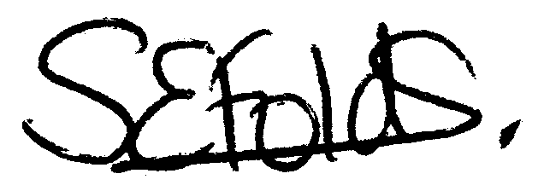

Samantha Folds - Clerk to Cury Parish Council

