CURY PARISH PLAN
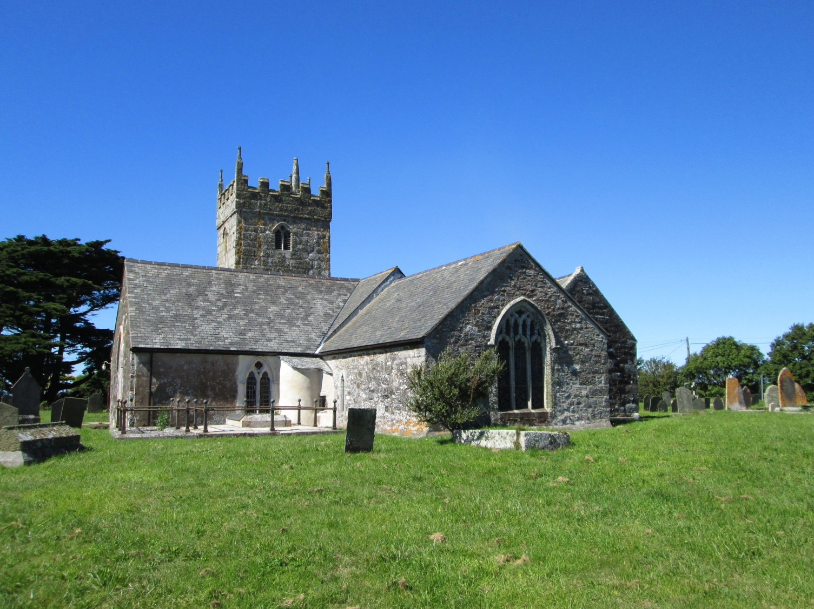
AN IMPROVED PARISH FOR RESIDENTS AND VISITORS, YOUNG AND OLD
Adopted January 2014
Contents Page Number

The Parish of Cury 3
A Brief History 3
Amenities 4
Purpose of the Parish Plan 5
How the Plan was produced 5
Vision Statement 5
The Actions/Policies 6

Transport and Traffic 7
Community Facilities 9
The Environment 12
Housing and Development 13
Sport, Leisure and Recreation 15
Work and Training 17
Health 19

The Future 20

The Parish of Cury

Cury is a rural Parish and lies just inland of the Atlantic coast on the western side of the Lizard Peninsula in West Cornwall. The Parish is divided into four hamlets: Nantithet, White Cross, Cross Lanes and Churchtown, together with a large area of farmland on the Southern side of the road to Gunwalloe. The Parish covers 1143 hectares in area and has approximately 400 residents.

Being a rural Parish made up of four small settlements, Cury lacks a defined centre and has few services and shops. There are no hotels, but there are several self-catering establishments, Bed and Breakfasts and Camping Sites. Since the original Plan was published, the only Village Shop has closed.

Cury is principally a farming community, with small family run farms. Before milk quotas, dairy farming was predominant but now local farmers have diversified into vegetable, flower, beef and sheep production.

The Lizard Peninsula lies within the Cornwall Area of Outstanding Natural Beauty (AONB) and the Parish is blessed with both beautiful surrounding countryside and nearby picturesque beaches and secluded coves of the Lizard Peninsula, such as Poldhu Cove and Church Cove, Gunwalloe, all of which are vital to our tourist industry.

A Brief History
In historical terms, the 11th Century church is dedicated to St. Corentyn and has many interesting features. The present Methodist Church was built in 1890 for the Wesleyans, costing at the time £700 to build. It was refurbishes in 1993.
The Village Hall was originally a mess hut at the old RNAS Mullion (a World War 1 Airship Station) and was moved to its present site in the Parish at White Cross in 1921. Several organisations meet at the hall on a regular basis, including the Women’s Institute, children’s groups and, since the closure of the Village Shop, the post office is held here on a Thursday morning. Events such as whist drives and bingo are held monthly and shows, such as the village show, annually. A local theatrical group hosts productions and weekly exercise classes are also now held in the Hall.
In May 1967, a new Church of England school was opened. This was the third school for Cury, and is the present Primary School.
There were originally 14 wind turbines producing electricity at nearby Bonython. These have recently been replaced by six larger turbines. They are a prominent feature on the landscape near Goonhilly Earth Station, a small section of which lies within the Parish of Cury.
Amenities
The lack of facilities in the Parish means that many residents travel to, e.g. nearby Mullion or Helston for shops, services and employment. Current facilities in Cury include:

White Cross

- Village Hall
- Methodist Chapel
- Communal Herb Box, telephone kiosk and post box

Cross Lanes

- Wheel Inn Pub

Churchtown
- Church
- Cury Primary School
- Jubilee Playing Field, Play equipment and Football Ground

The Purpose of the Parish Plan
The objectives of the Original Parish Plan, and this update Plan, are to set out an achievable and long-term vision for the future of the Parish, covering all issues that were identified as important within the Parish, ensuring that the community and local people have an influence in the prioritisation and implementation of measures to improve their living environment.
Since the formation of the Unitary Authority in Cornwall in 2009 (and since the original Plan was produced), the Kerrier District Local Plan is defunct. The Cornwall Local Plan 2010-2030 is still in development as at November 2013. Therefore this Plan does not feed in to the Authority’s Plans in any way. It is, however, hoped that, as a proper consultation has taken place to stimulate this update Plan, it should carry weight on decisions and/or suggestions that the Parish Council makes.
How the Plan was Produced
An open day was held in the Village Hall in August 2012. Residents were invited to view the original Plan and to see what work has been undertaken by the Parish Council to achieve some of the Actions in the Plan. They were also asked to give their suggestions for Actions to be placed in this updated Plan.
The Parish Council held a public meeting to discuss the suggestions and points raised following that meeting. The agreed Actions are now contained within this Plan.
It should be noted that this updated Plan should be viewed alongside the original Plan to give further background. See http://www.cornwall.gov.uk/default.aspx?page=21756 for a copy
Vision Statement
“An improved Parish for the benefit of residents and visitors, young and old”.
This vision for the future still holds good as it is hoped that the Parish will essentially stay as it is, while improving as required.

The Actions/Policies
The actions proposed for improvement of the Parish for the future include:
- Addressing the speed of vehicles passing through Nantithet
- Resurface the village hall car park
- Support affordable housing development when the need for additional houses arises
- Refurbishment of play equipment
- Support small businesses
- Ensure access to health services is maintained
- Ensuring the viability of the School for the children of the Parish

Transport and Traffic

1.0 Introduction

The highway network of the Lizard Peninsula is rural, incorporating winding narrow lanes. Road use increases greatly during the busy summer tourist season, which runs from Easter to the end of October. Cury lies off the A3083 Helston to Lizard road on an unclassified road. The main nearby town is Helston, and Mullion village is close by. Public transport includes a regular daily bus service through the Parish, providing links to Mullion, Helston and Truro, with connections to further a-field using standard size double and single decker buses. This bus service must be retained to provide access to the facilities and services in the places mentioned. It is essential for those without cars, particularly the elderly.

1.1 The Issues/Justification

The issue of traffic/transport was raised most at the consultation day, although it was recognised that the road calming installed since the original Plan has significantly reduced speeding through the village

Comments raised included:-

- The installation of a pavement from Whitecross to Churchtown
- Road calming at Nantithet
- Concern over ‘build out’ entering Cury from the direction of Mullion
- Mill Poll Lane unsuitable for large vehicles

1.2 The Vision

The original Plan stated ‘To provide a safe environment for all road users and pedestrians, by effectively lowering traffic speed in the Village’. This has been achieved through Churchtown and Whitecross, but attention needs to be turned to Nantithet. The speed limit is 60mph, but it was agreed that it was impossible to exceed 30mph due to the layout of the road. It was noted that no accidents had occurred on the build out, and that if it was moved further away from the bend, it would no longer prove useful in slowing vehicles to an acceptable speed to enter the village.

Policy | Action | Partners | Timescale
T1: Reduction of speed through Nantithet | a) Police radar traps on a regular basis  b) Potential traffic calming measures | Police  Cornwall Council Highways | Current and ongoing long term action
T2: Provision of new pavements in the village | Provide new pavements from Whitecross to Churchtown | Land and funding would be required | Ongoing long term action
T3: Unsuitable access through Mill Poll Lane | Installation of ‘Unsuitable for Large Vehicles’ sign at Treloskan and Churchtown | Cornwall Council Highways | Within one year
T4: Dangerous driving occurring over large speed cushion adjacent to School | Installation of bollards on pavement to stop vehicles mounting the kerb to avoid the speed cushion | Cornwall Council Highways | Within one month

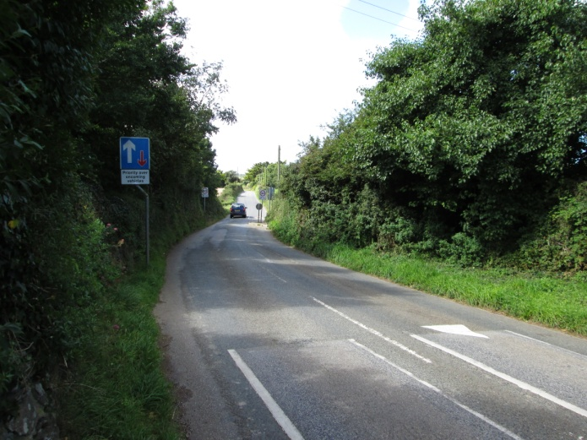

Community Facilities

2.0 Introduction

Cury is a small Parish with a few scattered community facilities; these include:-

- Primary School
- Village Hall
- Church
- Methodist Chapel
- Pub

It was a great loss to the village when the shop closed. However, Planning permission was sought and works are underway to convert the curtilage into a cafe and shop as at November 2013.

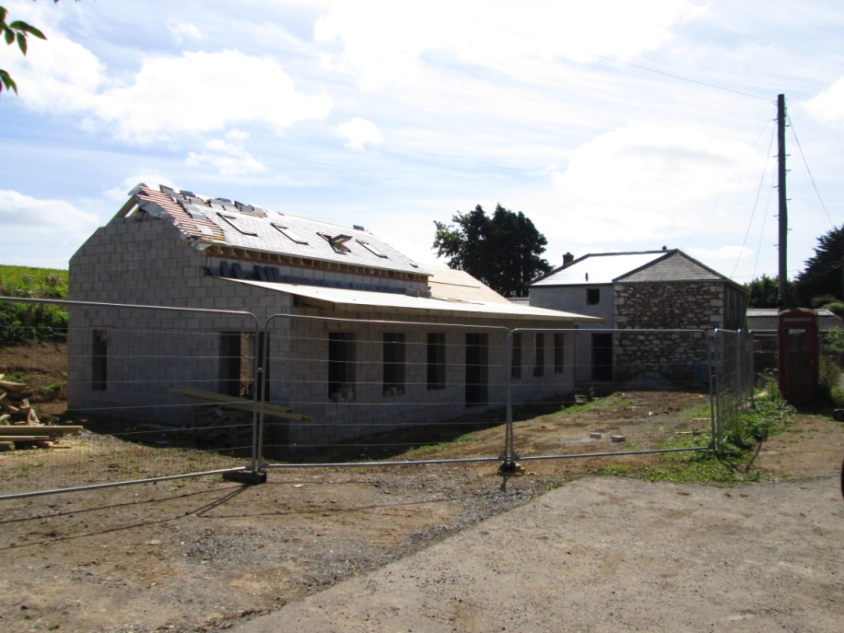
The school is a huge asset to the village as it provides the cohesion of the community for future generations. It is thought that out of hours educational and recreational opportunities could be provided for the local community by the facility.
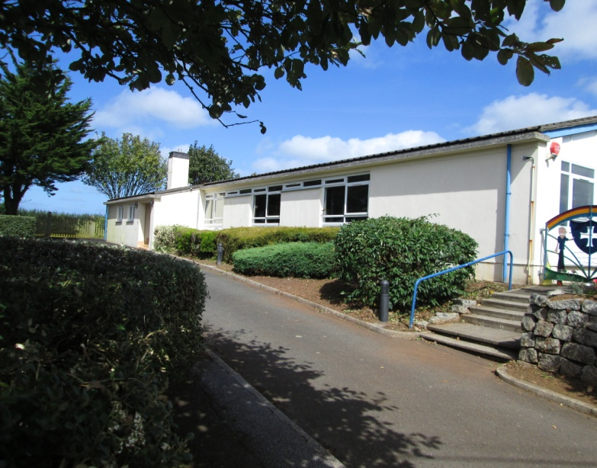
The Village Hall at Whitecross has undergone a significant amount of work since the publication of the original Plan. An enthusiastic committee has attracted grant funding for a new floor, replacement heaters as well as other improvements.
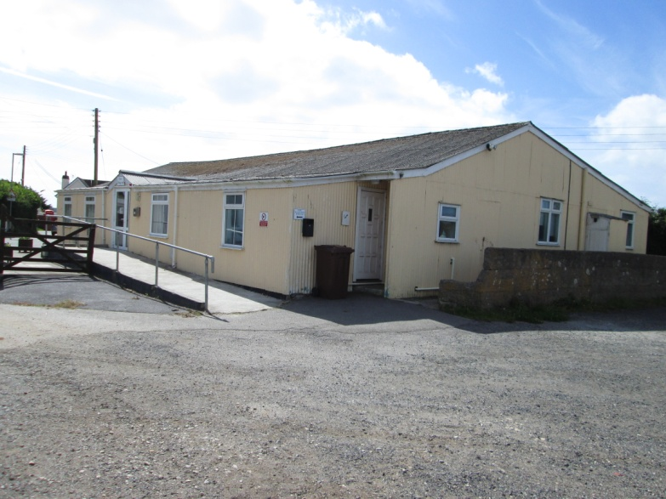

Bus shelters located at the Village Hall and School have been installed since the original Plan and are well used by the community.

2.1 The issues/justification

Concerns raised at the consultation day included dog waste bins, cutting of hedges and grass areas which are daily ‘operational’ issues and do not have a place in the Plan.

The resurfacing of the Village Hall car park was raised again, as well as the creation of car parking spaces in front of the changing rooms, which would reduce the size of the open space in the playing field.

2.2 The Vision

To enhance present community facilities.

Policy | Action | Partners | Timescale
CF1: Village Hall and car park | Resurfacing of the car park to be supported | The Village Hall Committee | Short term
CF2: Parking at the Playing Field | Clear the area behind the changing rooms for parking cars | CPC and Cury Football Club | Short term
CF3: Cury School | Links to continue to be developed between the School and the community. | CPC, Cury School, Cury Church, Ward Member | Ongoing

The Environment

3.0 Introduction

The whole of the Lizard peninsula (with the exception of Culdrose Naval Air Station) is situated within the Cornwall Area of Outstanding Natural Beauty (AONB) and therefore is a nationally statutorily designated area which receives a high status of protection with regards to scenic beauty. The settlements within the Parish of Cury are small and reflect the rural landscape of the Lizard Peninsula and the natural and built environment should be conserved and enhanced with any development managed sympathetically.

3.1 The issues/justification

The only issue raised was in relation to the recycling containers removed from the Village Hall car park in 2011. Many of the actions highlighted in the original Plan had been completed.

3.2 The Vision

The natural environment of the Parish should be conserved and enhanced for the benefit of all. Any development should reflect and blend in with the surroundings as appropriate within a designated AONB. The village environment should be attractive as a living space for the enjoyment of all the community.

Policy | Action | Partners | Timescale
E1: Sympathetic development | Any development must reflect and blend in with the surroundings as appropriate within the AONB | Cornwall Council | Ongoing

Housing and Development

4.0 Introduction

The Parish is relatively small with a population of about 400 residents, therefore any large scale development would not be desirable or indeed suitable due to the rural location. Lack of adequate infrastructure and the restrictions on development are imposed by the AONB designation. The original Parish Plan limited any development to the provision of affordable housing on one site within the Parish, if the need could be proven.

4.1 The issues/justification

No suggestions were made at the consultation day in relation to housing and development. Affordable housing has been built in the Parish since the original Plan. A recent housing survey found that there was no need for additional affordable housing in the Parish at the current time.

4.2 The Vision

No further large housing development proposals within the Parish, with the exception of affordable housing for local people, if the need was proven. The design of new dwellings should be of high standard and respect the surrounding area and existing buildings.

Policy | Action | Partners | Timescale
H1: Provision of affordable housing/social homes | Small number of affordable homes/social homes to be built when the need arises | CPC, Cornwall Council, housing associations, land owners | Long term
H2: Housing design | New housing development should be in keeping with local area and include a high standard of design and use of materials | CPC, Cornwall Council, local landowners and developers | Ongoing
H3: Development restrictions | No large scale development proposals (present of future) to be permitted within the Parish. Development should be limited to provision of affordable housing as mentioned in policy H1. | Cornwall Council, CPC | Ongoing

Sport, Leisure and Recreation

5.0 Introduction

The Jubilee Field is an important local asset, which is for use by all of the community. It provides sport and recreational facilities in the Parish, and these have recently been renovated and improved. Facilities of a larger scale are accessible to Parishioners in nearby Mullion and Helston.

The changing rooms had recently had new doors and windows installed to ensure the security of the facility. Funding for a new roof had also been granted to the Football Club and this has been completed.

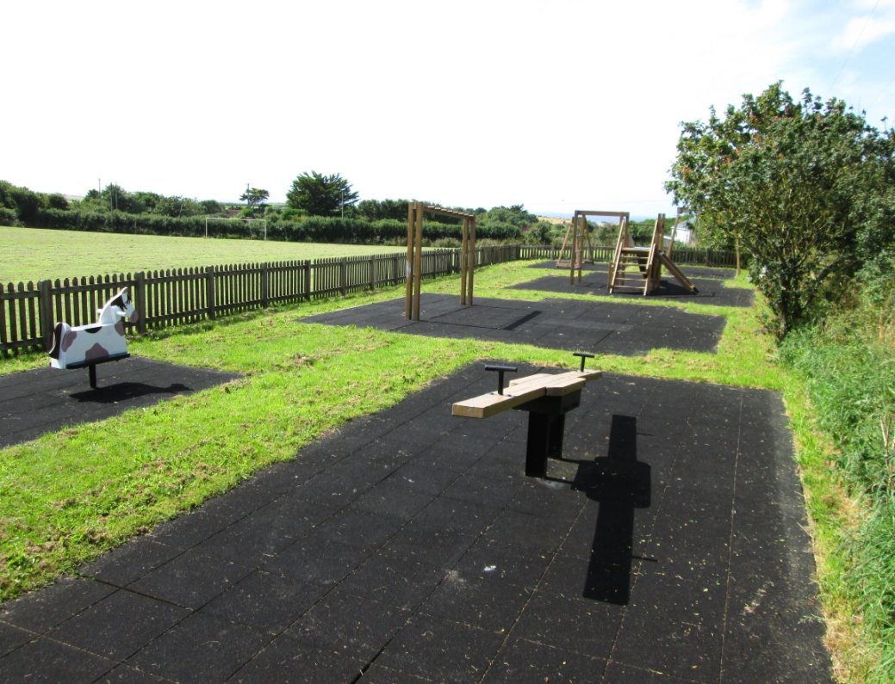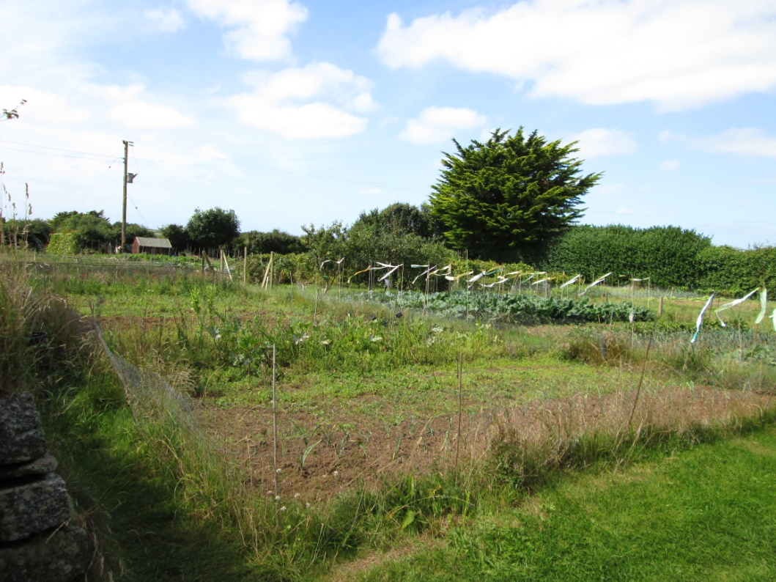

The Parish is fortunate to have four allotments, all of which are tenanted by local people and are well looked after.

The Parish Council also owns and manages the Cemetery, which has capacity to continue in the existing location for many years to come.

5.1 The Issues/Justification

The renovation of the existing play equipment was suggested, as was the communal use of the changing rooms and toilet facility. It should be noted that the changing rooms and toilets can be used by any group wishing to use the playing field, but that they must be locked to stop vandalism. The creation of parking spaces in and around the playing field was also suggested. As the Parish Council were the Trustees of the Playing Field, external grant funding was difficult to obtain. It has been suggested that if a Committee was set up to take over the running of the park, grant funding could be applied for to replace the play equipment.

5.2 The Vision

Modern and safe recreations and sport facilities accessible and available for all to use in the community.

Policy | Action | Partners | Timescale
L1: Refurbishment of changing rooms | New windows, doors and roof | CPC, Cury Football Club | Short term (commencing 2013)
L2: Refurbishment of play equipment | Replacing and renovating existing play equipment and surrounding fences | CPC | Short term (commencing 2013)
L3: Jubilee Playing Field Committee | To establish a Committee to enable grant funding to be sought | CPC, Cury Football Club, Community, Cornwall Rural Community Council | Short Term (commencing 2013)

Work and Training

6.0 Introduction

There are limited local employment opportunities within Cury with the majority of the workforce commuting to Mullion, Culdrose, Helston or further a-field. The opportunity for more local jobs would be desirable although, being a small rural Parish within an AONB, it would be impractical and indeed undesirable to accommodate any large development intended for employment purposes.

There are, however, rural workshops situated within the Parish off the A3083 Helston to Lizard road which are supported, especially for local business/job opportunities.

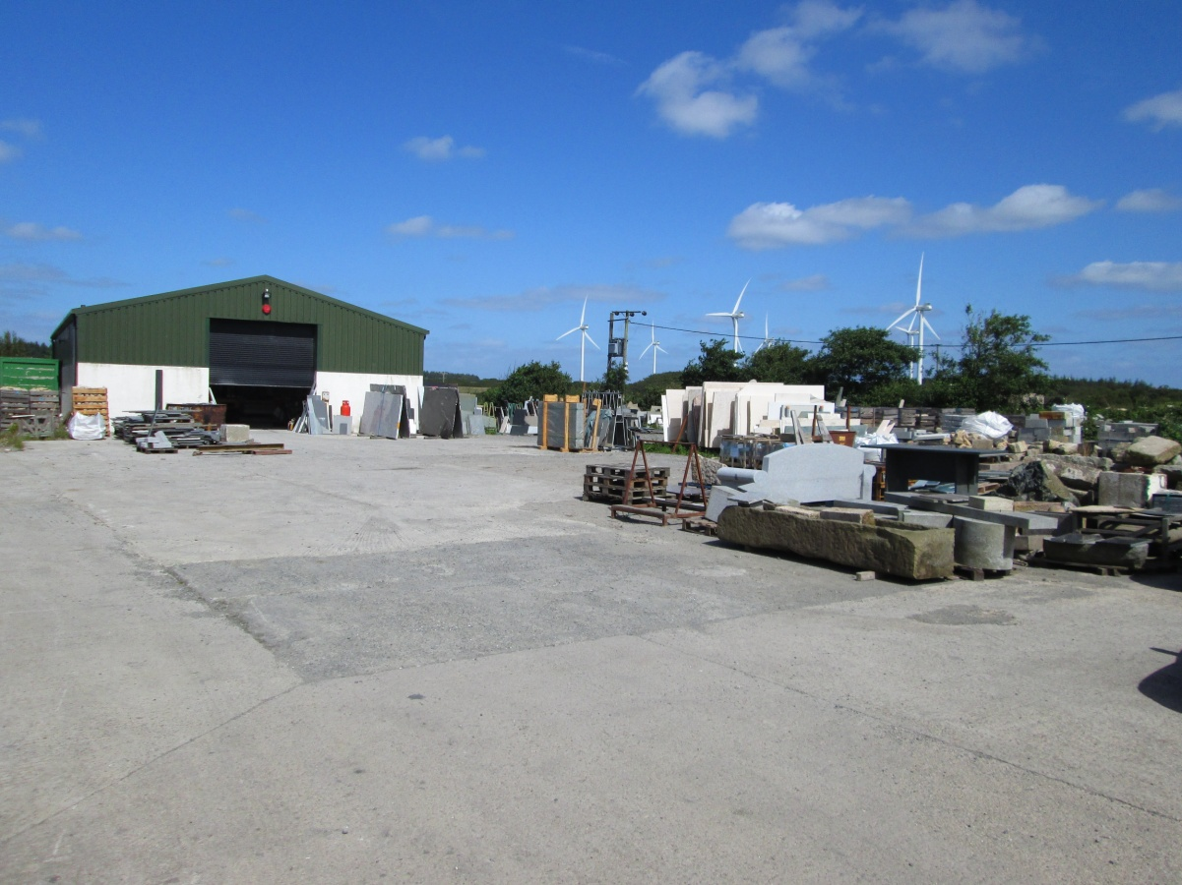

If, at any time, further small scale rural workshops are proposed in a suitable location within the Parish, which would not have any detrimental effects on the visual and natural environment, then they would be considered if it is shown they will be of benefit to the local economy/workforce of the Parish. For example, David Gilbert Joinery has recently moved into a converted agricultural shed in the Parish.
Any opportunities/schemes arising for new services/facilities which would generate local employment are encouraged and supported, as long as they are in keeping with the scale of the Parish and where there are obvious and identifiable benefits to the local community, either by diversification of existing services, or by new providers.

6.1 The Issues/Justification

No issues were raised at the Consultation Day.

6.2 The Vision

The provision of opportunities within the Parish for access to work and to support sustainable local job opportunities.

Policy | Action | Partners | Timescale
W1. Support and encouragement for small scale business and local employment opportunities | Support existing rural workshops and other proposals that are sensitive to the setting of a rural Parish | CPC, local services/businesses, employees | Ongoing

Health

7.0
Health issues were not mentioned at the Consultation Day. There is no doctor’s surgery or dentist in the Parish, however Parishioners use the surgeries in Mullion or Helston, both of which provide good health care provision. It is important that there is adequate access to these services and this should be ensured, supported and where possible improved upon in the future. The regular two hourly bus service through the village to Helston and Mullion is essential.

Policy | Action | Partners | Timescale
H1: Good level of access to health care provision and support for improved local health services | Ensure health services in Helston and Mullion are accessible to all in the Parish at all times, and show there is a need for more local based health services | CPC, health providers, bus service providers, Ward Member | Ongoing

The Future

The publication of this revised Plan is not the end of the Parish Plan process and actions that are proposed with the Plan will be revisited periodically.

Some issues will need outside help, while others can be tackled by, and within, the community. All the proposals and actions should be monitored, reviewed and updated over time to ensure that any changes within the community are incorporated into the Parish Plan document and process. Cury Parish Council will lead on this.

To be reviewed in November 2015.

The assistance of Cury residents is greatly appreciated.

