CURY PARISH COUNCIL

I hereby summon you to attend a Meeting of Cury Parish Council to be at 7.30pm on Wednesday 09 November 2016 in the Cury Methodist Chapel, Cury. The public and press are cordially invited to attend. Any plans are available to view from 7.15pm.

1. Apologies for Absence
2. Declarations of Interest – Members to declare personal and prejudicial interests (including details thereof) in respect of any item(s) on this Agenda
3. Chairman’s Comments
- To agree the Minutes of the Parish Council Meeting held on Wednesday 14 September 2016
5. Matters arising from the above approved minutes which are not covered in this agenda
6. Reports
(a) To receive the Report from Cury School
(b) To receive the Report from Cornwall Councillor W Sanger
(c) Helston and South Kerrier Community Network Panel - 7 December 2016 at 6pm
7. Planning
(a) To consider and respond to any Planning Applications received
(i) PA16/08196 – Mr M Johns – Doldavas, Cury Cross Lanes – Demolition of part of the existing single storey, flat roof garage and extension of garage to create a large garage, new utility room and ensuite bathroom
(ii) PA16/08942 – Mr Dyer – Land opposite Cobblers Cottage, Nantithet – Outline application for the erection of 4 dwellings with a common, sweeping shared driveway from a wide entrance
(b) To receive any Planning Decisions
(i) PA16/08405 – Mr & Mrs A Murray – The Lodge Cottage, White Cross – Proposed extension, internal alterations and garage – Approved
(ii) PA16/07688 - Mr & Mrs Lugg - Bos Skyber Cury Cross Lanes - Construction of a 40m x 20m outdoor menage with surrounding fencing - Approved
(c) To receive any further planning correspondence
8. Parish Matters
To consider the following:-
(a) Playing Field
(b) Highways
(c) Public Rights of Way
(d) Public Open Spaces (Cemetery, village green, etc)
(e) Emergency Plan
(f) Projects for Funding in the Village
(g) Speed Limits
9. Financial Matters
(a) To receive and approve the financial report for the previous two months
(b) To receive any LGA 1972 Section 137 Requests for grant funding
(c) Other matters
10. To agree the Calendar of Meetings for 2017
11. Correspondence
12. Matters for the next Parish Council Meeting
To receive notice of items to be included on the agenda for the next Parish Council Meeting scheduled to be held on Wednesday 11 January 2017 in the Cury Methodist Chapel

Council to withdraw if necessary under the Public Bodies Admissions to Meetings Act 1960 Section 1, Local Government Act 1972 Section 100 Sections 2 & 3 and Local Government Act 172 Schedule 12 Section 42. Given under my hand this First day of November 2016.

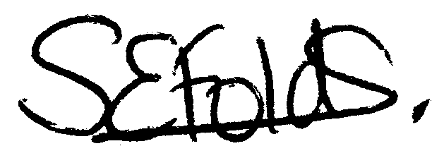
Samantha Folds – Clerk to Cury Parish Council

