CURY PARISH COUNCIL

I hereby summon you to attend a Meeting of Cury Parish Council to be held on Wednesday 08 September 2021 at 7.30pm in the Cury Methodist Chapel, Cury. The public and press are cordially invited to attend.

1. Apologies for Absence
2. Election of a Vice Chairman
3. Declarations of Interest – Members to declare personal and disclosable pecuniary interests (including details thereof) in respect of any item(s) on this Agenda
4. Chairman’s Comments
5. To agree the Minutes of the Parish Council Meeting held on Wednesday 14 July 2021
6. Matters arising from the above approved minutes which are not covered in this agenda
7. Reports
(a) To receive the Report from Cury School
(b) To receive the Report from Cornwall Councillor Anthony Soady
(c) Helston and South Kerrier Community Network Panel – Councillor S Sugrue
8. Planning
(a) To consider and respond to any Planning Applications received
(b) To receive any Planning Decisions
(c) To ratify the following decisions
(i) PA21/06704 - Mr R Curnow - Nanfan Farm, Churchtown - Extension to Existing Agricultural Building
(ii) PA21/06440 - Mr D Light - Land North East Of Parc Drea. Nantithet - Outline application to replace diving pool and associated buildings with a residential caravan for owners/managers accommodation with all matters reserved except access
(d) To receive any further planning correspondence
9. Parish Matters
To consider the following:-
(a) Play Equipment Proposal
(b) Playing Field
(c) Highways
(d) Public Rights of Way
(e) Public Open Spaces (Cemetery, village green, etc)
(f) Emergency Plan
10. Financial Matters
(a) To receive and approve the financial report for the previous two months
(b) To receive any LGA 1972 Section 137 Requests for grant funding
(c) Other matters
11. Matters for the next Parish Council Meeting
To receive notice of items to be included on the agenda for the next Parish Council Meeting scheduled to be held on Wednesday 10 November 2021 in the Cury Methodist Chapel

Council to withdraw if necessary under the Public Bodies Admissions to Meetings Act 1960 Section 1, Local Government Act 1972 Section 100 Sections 2 & 3 and Local Government Act 172 Schedule 12 Section 42. Given under my hand this First day of September 2021.

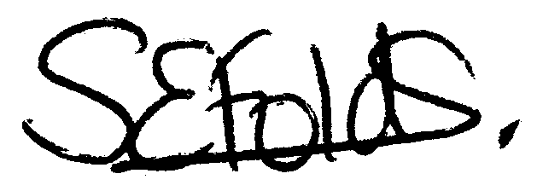

Samantha Folds - Clerk to Cury Parish Council

