CURY PARISH COUNCIL

I hereby summon you to attend a Meeting of Cury Parish Council to be held on Wednesday 12 January 2022 at 7.30pm in the Gunwalloe Village Hall, Gunwalloe. The public and press are cordially invited to attend.

1. Apologies for Absence
2. Declarations of Interest – Members to declare personal and disclosable pecuniary interests (including details thereof) in respect of any item(s) on this Agenda
3. Chairman’s Comments
4. To agree the Minutes of the Parish Council Meeting held on Wednesday 10 November 2021
5. Matters arising from the above approved minutes which are not covered in this agenda
6. Reports
(a) To receive the Report from Cury School
(b) To receive the Report from Cornwall Councillor Anthony Soady
(c) Helston and South Kerrier Community Network Panel – Councillor S Sugrue
7. Planning
(a) To consider and respond to any Planning Applications received
(i) Ratify – PA21/10805 – Poledan House, Nanfant – Proposed detached single garage
(b) To receive any Planning Decisions
(i) PA21/09438 - Messrs Saville & Palmer - Gweal Wollas, White Cross - Proposed extensions to house and formation of detached garage
(c) To receive any further planning correspondence
8. Parish Matters
To consider the following:-
(a) Play Equipment Proposal
(b) Playing Field
(c) Highways – including Cornwall Cllr Soady’s idea of the removal of the speed humps
(d) Public Rights of Way
(e) Public Open Spaces (Cemetery, village green, etc)
(f) Emergency Plan
9. Financial Matters
(a) To agree the Precept Demand for 2022/23
(b) To receive and approve the financial report for the previous two months
(c) To receive any LGA 1972 Section 137 Requests for grant funding – Village Hall
(d) Community Infrastructure Levy Payments from Cornwall Council
(e) Other matters
10. 100 year Commemorative Plaque presented to the PC by Kerrier District Council
11. Matters for the next Parish Council Meeting
To receive notice of items to be included on the agenda for the next Parish Council Meeting scheduled to be held on Wednesday 09 March 2022 in a location to be decided

The Council is invited to pass the following resolution “that pursuant to the Public Bodies (Admissions to Meetings) Act 1960, the press and public be excluded from the meeting for the following items of business by reason of the confidential nature of the business to be transacted”.

12. Planning Enforcement Cases

Given under my hand this Fourth day of January 2022.

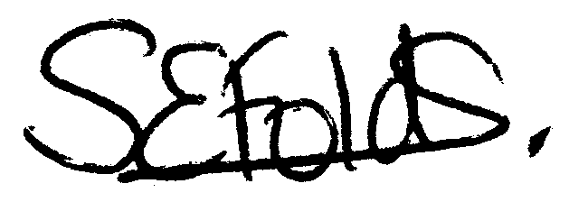

Samantha Folds - Clerk to Cury Parish Council

