CURY PARISH COUNCIL

I hereby summon you to attend a Meeting of Cury Parish Council to be held on Thursday 27 July 2023 at 7.00pm in the Cury Village Hall, Cury. The public and press are cordially invited to attend.

1. Apologies for Absence
2. Declarations of Interest – Members to declare personal and prejudicial interests (including details thereof) in respect of any item(s) on this Agenda
3. Chairman’s Comments
- To agree the Minutes of the Annual Meeting and the Parish Council Meeting held on Thursday 25 May 2023
5. Matters arising from the above approved minutes which are not covered in this agenda
6. Reports
(a) To receive an update on Cury School
(b) To receive the Report from Cornwall Councillor
(c) Helston and South Kerrier Community Network Panel
7. Planning
(a) To consider and respond to any Planning Applications received
(i) PA23/04911 - Mr J Trounson - Agricultural Shed at Colvennor Farm - change of use from agricultural shed to residential dwelling, including associated landscaping and external works
(b) To receive any Planning Decisions
(i) PA23/01395 - Franchis Holiday Park, Bochym Hill - Proposed siting of 1no. static holiday home on 'The Meadow' to the rear of the park - Approved
8. Parish Matters
To consider the following:-
(a) Playing Field
(b) Highways
(c) Public Rights of Way
(d) Public Open Spaces (Cemetery, village green, etc)
(e) Emergency Plan
9. To complete the Conflict of Interest with BDO Audit form
10. Financial Matters
(a) To receive and approve the financial report for the previous two months
(b) To receive any LGA 1972 Section 137 Requests for grant funding
(c) Other matters
11. Correspondence
12. Matters for the next Parish Council Meeting
To receive notice of items to be included on the agenda for the next Parish Council Meeting scheduled to be held on Thursday 28 September 2022 in the Gunwalloe Village Hall

Council to withdraw if necessary under the Public Bodies Admissions to Meetings Act 1960 Section 1, Local Government Act 1972 Section 100 Sections 2 & 3 and Local Government Act 172 Schedule 12 Section 42. Given under my hand this Twentieth day of July 2023.

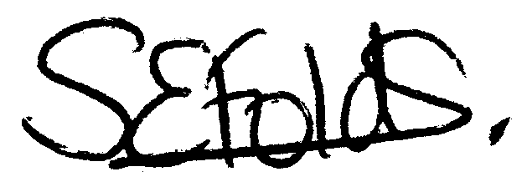

Samantha Folds
Clerk to Cury Parish Council

