CURY PARISH COUNCIL

I hereby summon you to attend an Extraordinary Meeting of Cury Parish Council to be held at 7.30pm on Wednesday 04 June 2014 in the Cury Methodist Chapel, Cury. The public and press are cordially invited to attend. Any plans are available to view from 7.15pm.

1. Apologies for Absence

2. Declarations of Interest – Members to declare personal and prejudicial interests (including details thereof) in respect of any item(s) on this Agenda

3. To agree the Minutes of the Annual Parish Meeting and the Parish Council Meeting held on Wednesday 14 May 2014

4. Planning Matters

(a) To consider and respond to any Planning Applications received

(i) PA14/04032 - Mr R Curnow - Nanfan Farm, Churchtown - Formation of an agricultural shed

(b) To receive any Planning Decisions

(c) To receive any further planning correspondence

Council to withdraw if necessary under the Public Bodies Admissions to Meetings Act 1960 Section 1, Local Government Act 1972 Section 100 Sections 2 & 3 and Local Government Act 172 Schedule 12 Section 42. Given under my hand this Twenty Seventh day of May 2014.

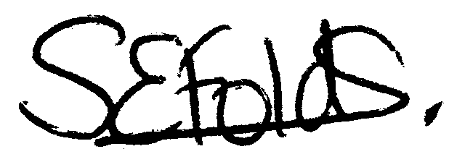

Samantha Folds - Clerk to Cury Parish Council

