CURY PARISH COUNCIL

I hereby summon you to attend a Meeting of Cury Parish Council to be held on Thursday 23 March 2023 at 7.00pm in the Cury Village Hall, Cury. The public and press are cordially invited to attend.

1. Apologies for Absence
2. Declarations of Interest – Members to declare personal and prejudicial interests (including details thereof) in respect of any item(s) on this Agenda
3. Chairman’s Comments
- To agree the Minutes of the Parish Council Meeting held on Thursday 26 January 2023
5. Matters arising from the above approved minutes which are not covered in this agenda
6. Reports
(a) To receive an update on Cury School
(b) To receive the Report from Cornwall Councillor Anthony Soady
(c) Helston and South Kerrier Community Network Panel
7. Planning
(a) To consider and respond to any Planning Applications received
(i) PA23/01202 – Pol Glas Hall, Nanfant, Churchtown – Solar panels on roof, outbuilding and balcony extension
(ii) PA23/01821 - Pol Glas Cabin, Nanfant, Churchtown Cury - Addition of Solar Panels to Existing Building
(b) To receive any Planning Decisions
(i) PA22/04961 - Construction of new four bedroom, two storey dwelling with Agricultural Occupancy Condition. - Higher Skewes Farm Cury Cross Lanes - Approved
(c) To receive any further planning correspondence
8. Parish Matters
To consider the following:-
(a) Playing Field
(b) Highways
(c) Public Rights of Way
(d) Public Open Spaces (Cemetery, village green, etc)
(e) Emergency Plan
9. Financial Matters
(a) To receive and approve the financial report for the previous two months
(b) To receive any LGA 1972 Section 137 Requests for grant funding
(c) Other matters
10. Correspondence
11. Matters for the next Parish Council Meeting
To receive notice of items to be included on the agenda for the next Parish Council Meeting scheduled to be held on Thursday 23 March 2022 in the Cury Village Hall

Council to withdraw if necessary under the Public Bodies Admissions to Meetings Act 1960 Section 1, Local Government Act 1972 Section 100 Sections 2 & 3 and Local Government Act 172 Schedule 12 Section 42. Given under my hand this Seventeenth Day of March 2023.

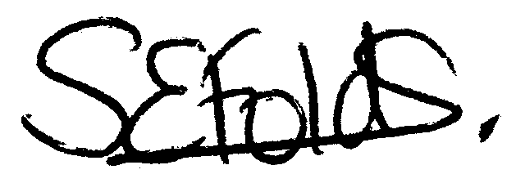

Samantha Folds
Clerk to Cury Parish Council

