CURY PARISH COUNCIL

I hereby summon you to attend a Meeting of Cury Parish Council to be held following the AGM (which commences at 7.30pm) on Wednesday 13 May 2015 in the Cury Methodist Chapel, Cury. The public and press are cordially invited to attend. Any plans are available to view from 7.15pm.

1. Apologies for Absence
2. Declarations of Interest – Members to declare personal and prejudicial interests (including details thereof) in respect of any item(s) on this Agenda
3. Chairman’s Comments
- To agree the Minutes of the Parish Council Meeting held on Wednesday 13 March 2015
5. Matters arising from the above approved minutes which are not covered in this agenda
6. Reports
(a) To receive the Police Report
(b) To receive the Report from Cury School
(c) To receive the Report from Cornwall Councillor W Sanger
(d) Helston and South Kerrier Community Network Panel

7. Planning
(a) To consider and respond to any Planning Applications received
(b) To receive any Planning Decisions
(i) PA15/00537 - Mr And Mrs M Laity - Land Adj Corantyn Cottage, Cury - Erection of single 2 storey dwelling - Approved
(c) To receive any further planning correspondence

8. Parish Matters
To consider the following:-
(a) Playing Field
(b) Highways, including the provision of a pavement from Nantithet to White Cross
(c) Public Rights of Way
(d) Public Open Spaces (Cemetery, village green, etc)
(e) Emergency Plan
(f) Footpath from Nantithet to White Cross
9. To consider affiliating to the Cornwall Association of Local Councils for 2015/16
10. To discuss the Insurance renewal for 2015/16
11. Financial Matters
(a) Annual Accounts to Year End 31 March 2015
i) To receive and approve the internally audited accounts for the Year Ending 31 March 2015
ii) To complete the Annual Governance Statement for the Year Ending 31 March 2015
iii) To receive and note the report of the Internal Auditor
iv) To appoint an Internal Auditor for 2015-16
(b) To receive and approve the financial report for the previous two months
(c) To receive any LGA 1972 Section 137 Requests for grant funding
(d) Other matters
12. Correspondence
13. Matters for the next Parish Council Meeting
To receive notice of items to be included on the agenda for the next Parish Council Meeting scheduled to be held on Wednesday 08 July 2015 in the Cury Methodist Chapel

Council to withdraw if necessary under the Public Bodies Admissions to Meetings Act 1960 Section 1, Local Government Act 1972 Section 100 Sections 2 & 3 and Local Government Act 172 Schedule 12 Section 42. Given under my hand this Fifth day of May 2015.

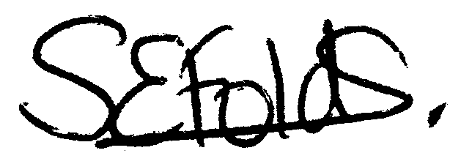

Samantha Folds - Clerk to Cury Parish Council

