CURY PARISH COUNCIL

I hereby summon you to attend a Meeting of Cury Parish Council to be held on Thursday 24 November 2022 at 7.00pm in the Cury Village Hall, Cury. The public and press are cordially invited to attend.

1. Apologies for Absence
2. Declarations of Interest – Members to declare personal and prejudicial interests (including details thereof) in respect of any item(s) on this Agenda
3. Chairman’s Comments
- To agree the Minutes of the Parish Council Meeting held on Thursday 29 September 2022
5. Matters arising from the above approved minutes which are not covered in this agenda
6. Reports
(a) To receive an update on Cury School
(b) To receive the Report from Cornwall Councillor Anthony Soady
(c) Helston and South Kerrier Community Network Panel
7. Planning
(a) To consider and respond to any Planning Applications received
(i) PA22/08099 – Higher Bochym Farm, Bochym Hill – Thirty ground mounted solar panels
(b) To receive any Planning Decisions
(i) PA21/12608 - North of Trevow Barn, White Cross - Erection of an agricultural building for general purpose agricultural storage, construction of stables, and New Vehicular Access – Approved
(ii) PA22/05760 - Gweal Wollas, White Cross - Construction of extension to provide boiler room – Approved
(iii) PA22/08018 - Mr Charles Haskell - Little Treloskan, road from Mainlay To Gilly Hill - Proposed kitchen extension to replace conservatory, with additional bedroom at first floor and handrail added to existing balcony - Approved
(c) To receive any further planning correspondence
8. Parish Matters
To consider the following:-
(a) Playing Field
(b) Highways
(c) Public Rights of Way
(d) Public Open Spaces (Cemetery, village green, etc)
(e) Emergency Plan
9. To discuss the Precept Demand for 2023/24
10. To discuss the Community Network Review
11. To approve the Calendar of Meetings for 2023
12. Financial Matters
(a) To receive and approve the financial report for the previous two months
(b) To receive any LGA 1972 Section 137 Requests for grant funding
(c) Other matters
13. Correspondence
14. Matters for the next Parish Council Meeting
To receive notice of items to be included on the agenda for the next Parish Council Meeting scheduled to be held on Thursday 26 January 2022 in the Cury Village Hall

Council to withdraw if necessary under the Public Bodies Admissions to Meetings Act 1960 Section 1, Local Government Act 1972 Section 100 Sections 2 & 3 and Local Government Act 172 Schedule 12 Section 42. Given under my hand this Fifteenth day of November 2022.

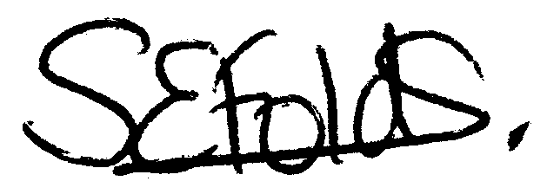

Samantha Folds
Clerk to Cury Parish Council

