CURY PARISH COUNCIL

I hereby summon you to attend an Extraordinary Meeting of Cury Parish Council to be held at 7.30pm on Wednesday 11 February 2015 in the Cury Methodist Chapel, Cury. The public and press are cordially invited to attend. Any plans are available to view from 7.15pm.

1. Apologies for Absence

2. Declarations of Interest – Members to declare personal and prejudicial interests (including details thereof) in respect of any item(s) on this Agenda

3. To agree the Minutes of the Parish Council Meeting held on Wednesday 14 January 2014

4. Planning Matters

(a) To consider and respond to any Planning Applications received

PA15/00537 – Mr & Mrs Laity – Land adjacent to Corantyn Cottage, Cury – Erection of a single two storey dwelling

(b) To receive any Planning Decisions

(c) To receive any further planning correspondence

Council to withdraw if necessary under the Public Bodies Admissions to Meetings Act 1960 Section 1, Local Government Act 1972 Section 100 Sections 2 & 3 and Local Government Act 172 Schedule 12 Section 42. Given under my hand this Third day of February 2015.

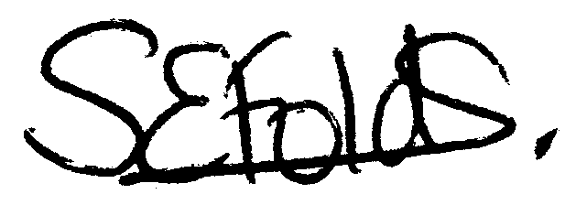

Samantha Folds
Clerk to Cury Parish Council

