CURY PARISH COUNCIL

I hereby summon you to attend a Meeting of Cury Parish Council to be held on Wednesday 10 March 2021 remotely at 7.30pm - online or by telephone via Microsoft Teams. The public and press are cordially invited to attend. Joining instructions are available by emailing the Clerk on curypc@btinternet.com or by calling 01326 572065.

1. Apologies for Absence
2. Declarations of Interest – Members to declare personal and disclosable pecuniary interests (including details thereof) in respect of any item(s) on this Agenda
3. Chairman’s Comments
4. To agree the Minutes of the Extraordinary Parish Council Meeting held on Wednesday 13 January 2021
5. Matters arising from the above approved minutes which are not covered in this agenda
6. Reports
(a) To receive the Report from Cury School
(b) To receive the Report from Cornwall Councillor Julian Rand
(c) Helston and South Kerrier Community Network Panel – Councillor S Sugrue
7. Planning
(a) To consider and respond to any Planning Applications received
(b) To receive any Planning Decisions
PA20/10045 – Mr V Williams – Barn, White Cross - Conversion of barn to form a dwelling –
Approved
PA20/09164 - Mr A McNish - Campsite Higher Bochym Farm - Change of use from existing planning consent (PA16/01296 for 6 glamping tents) to 6 caravan and motorhome pitches – Approved
PA20/11500 – Mrs A Terry- Fairways, Parknoweth, Churchtown - Replace the storm porch. Convert the garage to a bedroom. Replace the conservatory - Approved
(c) To receive any further planning correspondence
8. Parish Matters
To consider the following:-
(a) Playing Field
(b) Highways
(c) Public Rights of Way including the Local Maintenance Partnership Offer 2021-22
(d) Public Open Spaces (Cemetery, village green, etc)
(e) Emergency Plan
9. Financial Matters
(a) To receive and approve the financial report for the previous two months
(b) To receive any LGA 1972 Section 137 Requests for grant funding
(c) Other matters
10. Matters for the next Parish Council Meeting
To receive notice of items to be included on the agenda for the next Parish Council Meeting scheduled to be held on Wednesday 12 May 2021 in the Cury Methodist Chapel

Council to withdraw if necessary under the Public Bodies Admissions to Meetings Act 1960 Section 1, Local Government Act 1972 Section 100 Sections 2 & 3 and Local Government Act 172 Schedule 12 Section 42. Given under my hand this Third day of March 2021.

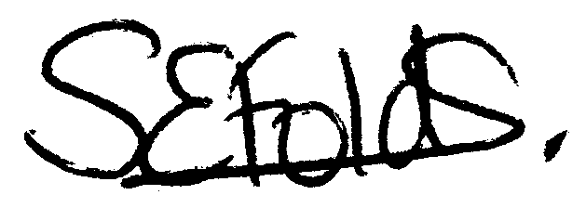

Samantha Folds - Clerk to Cury Parish Council

