CURY PARISH COUNCIL

I hereby summon you to attend a Meeting of Cury Parish Council to be held at 7.30pm on Wednesday 14 January 2014 in the Cury Methodist Chapel, Cury. The public and press are cordially invited to attend. Any plans are available to view from 7.15pm.

1. Apologies for Absence
2. Declarations of Interest – Members to declare personal and prejudicial interests (including details thereof) in respect of any item(s) on this Agenda
3. Chairman’s Comments
- To agree the Minutes of the Parish Council Meeting held on Wednesday 12 November 2014
5. Matters arising from the above approved minutes which are not covered in this agenda
6. Reports
(a) To receive the Police Report
(b) To receive the Report from Cury School
(c) To receive the Report from Cornwall Councillor W Sanger
(d) Helston and South Kerrier Community Network Panel
7. Planning
(a) To consider and respond to any Planning Applications received

(b) To receive any Planning Decisions
PA14/08366 – Mr & Mrs Whittaker - Byghan Drea Nantithet Cury - To add a section of redundant land in the ownership of the applicant to the domestic curtilage of Byghan Dre - Approved
PA14/08863 - Mr R Lugg - Bos Skyber, Cury Cross Lanes - The erection of a polytunnel measuring 9 metres by 16 metres with a highest point of 3.5 meters for the use of lambing sheep during the winter months

(c) To discuss the provision of Affordable Housing

(d) To receive any further planning correspondence

8. Parish Matters
To consider the following:-
(a) Playing Field
(b) Highways
(c) Public Rights of Way
(d) Public Open Spaces (Cemetery, village green, etc)

9. Financial Matters
(a) To receive and approve the financial report for the previous two months
(b) To receive any LGA 1972 Section 137 Requests for grant funding
(c) To set the Precept for 2015/16
(d) Other matters
10. Correspondence
11. Matters for the next Parish Council Meeting
To receive notice of items to be included on the agenda for the next Parish Council Meeting scheduled to be held on Wednesday 11 March 2015 in the Cury Methodist Chapel

Council to withdraw if necessary under the Public Bodies Admissions to Meetings Act 1960 Section 1, Local Government Act 1972 Section 100 Sections 2 & 3 and Local Government Act 172 Schedule 12 Section 42. Given under my hand this Sixth day of January 2015.

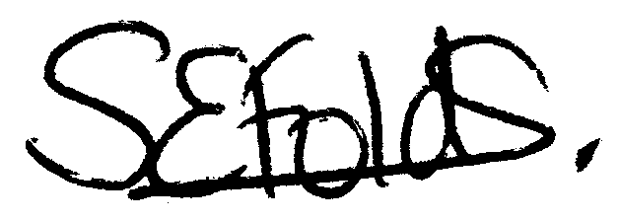
Samantha Folds
Clerk to Cury Parish Council

