CURY PARISH COUNCIL

I hereby summon you to attend an Extraordinary Meeting of Cury Parish Council to be held
at 7.30pm on Wednesday 16 December 2020 - online or by telephone via Microsoft Teams. The public and press are cordially invited to attend. Joining instructions are available by emailing the Clerk on curypc@btinternet.com or by calling 01326 572065

1. Apologies for Absence

2. Declarations of Interest – Members to declare pecuniary and non-pecuniary interests (including details thereof) in respect of any item(s) on this Agenda

3. To agree the Minutes of the Parish Council Meeting held on Wednesday 11 November 2020

4. Planning
(a) To consider and respond to any Planning Applications received
(i) PA20/10045 – Mr V Williams – Barn, White Cross - Conversion of barn to from a dwelling
(ii) PA20/09164 - Mr A McNish - Change of use from existing planning consent (PA16/01296 for 6 glamping tents) to 6 caravan and motorhome pitches - Campsite Higher Bochym Farm Bochym Hill, Cury Cross Lanes

(b) To receive any Planning Decisions

(c) To receive any further planning correspondence

5. To discuss the Precept Demand for 2021/22

Council to withdraw if necessary under the Public Bodies Admissions to Meetings Act 1960 Section 1, Local Government Act 1972 Section 100 Sections 2 & 3 and Local Government Act 172 Schedule 12 Section 42. Given under my hand this Eighth day of December 2020.

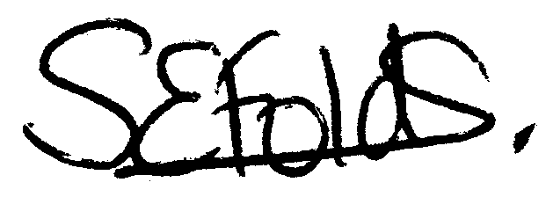

Samantha Folds - Clerk to Cury Parish Council

