CURY PARISH COUNCIL

I hereby summon you to attend a Meeting of Cury Parish Council to be at 7.30pm on Wednesday 14 September 2016 in the Cury Methodist Chapel, Cury. The public and press are cordially invited to attend. Any plans are available to view from 7.15pm.

1. Apologies for Absence

2. Declarations of Interest – Members to declare personal and prejudicial interests (including details thereof) in respect of any item(s) on this Agenda

3. Chairman’s Comments

- To agree the Minutes of the Parish Council Meeting held on Wednesday 13 July 2016

5. Matters arising from the above approved minutes which are not covered in this agenda

6. Reports
(a) To receive the Report from Cury School
(b) To receive the Report from Cornwall Councillor W Sanger
(c) Helston and South Kerrier Community Network Panel

7. Planning
(a) To consider and respond to any Planning Applications received
(i) PA16/07688 – Mr & Mrs Lugg – Bos Skyber, Cury Cross Lanes – Construction of a 40m x 20m outdoor ménage with surrounding fencing
(b) To receive any Planning Decisions
(c) To receive any further planning correspondence

8. Parish Matters
To consider the following:-
(a) Playing Field
(b) Highways
(c) Public Rights of Way
(d) Public Open Spaces (Cemetery, village green, etc)
(e) Emergency Plan
(f) Projects for Funding in the Village
(g) Nantithet Speed Limit

9. Financial Matters
(a) To receive the completed Annual Audit for 2015/16
(b) To receive and approve the financial report for the previous two months
(c) To receive any LGA 1972 Section 137 Requests for grant funding
(d) Other matters

10. Correspondence

11. Matters for the next Parish Council Meeting
To receive notice of items to be included on the agenda for the next Parish Council Meeting scheduled to be held on Wednesday 09 November 2016 in the Cury Methodist Chapel

Council to withdraw if necessary under the Public Bodies Admissions to Meetings Act 1960 Section 1, Local Government Act 1972 Section 100 Sections 2 & 3 and Local Government Act 172 Schedule 12 Section 42. Given under my hand this Sixth day of September 2016.

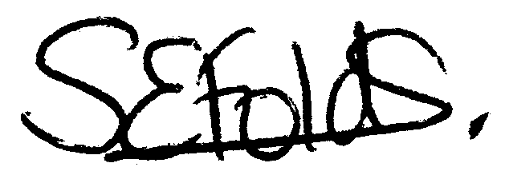
Samantha Folds - Clerk to Cury Parish Council

