CURY PARISH COUNCIL

I hereby summon you to attend a Meeting of Cury Parish Council to be held on Wednesday 14 July 2021 at 7.30pm in the Cury Methodist Chapel, Cury. The public and press are cordially invited to attend.

1. Apologies for Absence
2. Co-option of a New Councillor
3. Election of a Vice Chairman
4. Declarations of Interest – Members to declare personal and disclosable pecuniary interests (including details thereof) in respect of any item(s) on this Agenda
5. Chairman’s Comments
6. To agree the Minutes of the Annual Parish Meeting and the Parish Council Meeting held on Wednesday 12 May 2021
7. Matters arising from the above approved minutes which are not covered in this agenda
8. Reports
(a) To receive the Report from Cury School
(b) To receive the Report from Cornwall Councillor Anthony Soady
(c) Helston and South Kerrier Community Network Panel – Councillor S Sugrue
9. Planning
(a) To consider and respond to any Planning Applications received
(b) To receive any Planning Decisions
(i) PA21/03223 - Mr S Bell - Chy An Praze, Nantithet - Replacement of an agricultural building which was demolished for health and safety reasons – Approved
(ii) PA21/04973 - Mr And Mrs Philip Holt – Trewhella, Bochym Hill - Non material amendment to PA18/10768 - proposed alterations and extension including replacement garage - Approved
(c) To receive any further planning correspondence
10. Parish Matters
To consider the following:-
(a) Playing Field
(b) Highways
(c) Public Rights of Way
(d) Public Open Spaces (Cemetery, village green, etc)
(e) Emergency Plan
11. Adoption of the Code of Conduct 2021 version
12. Financial Matters
(a) To receive and approve the financial report for the previous two months
(b) To receive any LGA 1972 Section 137 Requests for grant funding
(c) Other matters
13. Matters for the next Parish Council Meeting
To receive notice of items to be included on the agenda for the next Parish Council Meeting scheduled to be held on Wednesday 08 September 2021 in the Cury Methodist Chapel

Council to withdraw if necessary under the Public Bodies Admissions to Meetings Act 1960 Section 1, Local Government Act 1972 Section 100 Sections 2 & 3 and Local Government Act 172 Schedule 12 Section 42. Given under my hand this Seventh day of July 2021.

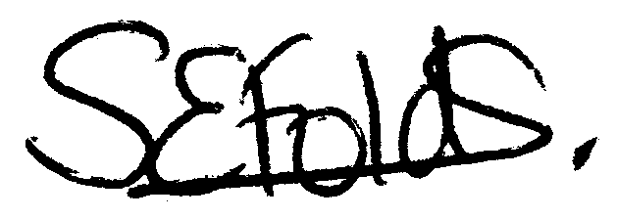

Samantha Folds - Clerk to Cury Parish Council

