CURY PARISH COUNCIL

I hereby summon you to attend a Meeting of Cury Parish Council to be held on Thursday 28 July 2022 at 7.00pm in the Cury Village Hall, Cury. The public and press are cordially invited to attend.

1. Apologies for Absence
2. Declarations of Interest – Members to declare personal and prejudicial interests (including details thereof) in respect of any item(s) on this Agenda
3. Chairman’s Comments
- To agree the Minutes of the Annual Electors Meeting and the Parish Council Meeting held on Wednesday 26 May 2022
5. Matters arising from the above approved minutes which are not covered in this agenda
6. Reports
(a) To receive an update on Cury School
(b) To receive the Report from Cornwall Councillor
(c) Helston and South Kerrier Community Network Panel
7. Planning
(a) To consider and respond to any Planning Applications received
(i) PA22/04651 - Mrs Emma Robinson - Gwenton Farm, Bochym Hill, Cury Cross Lanes - Change of use from agricultural land to campsite (tents only) for 6 months per year April to September with provision of portable toilets and showers, reverting to agricultural land for October to March
(ii) PA22/04961 - Mr H Dark - Higher Skewes Farm, Cury Cross Lanes - Construction of new four bedroom, two storey dwelling with Agricultural Occupancy Condition
(iii) PA22/05760 - Messers T & J Saville & Palmer - Gweal Wollas, White Cross - Construction of extension to provide boiler room
(iv) PA21/12608 – Mr & Mrs T Williams – Agricultural building north of Trevow Barn, White Cross – Erection of an agricultural building for general purpose agricultural storage and stables and new vehicular access
(b) To receive any Planning Decisions
(i) PA21/08066 - Mr Richard Nathan - Land And Buildings West Of Bonython Farmhouse, Bonython Estate, Cury Cross Lanes - Proposed conversion of redundant barns and farmyard to 8 holiday cottages and multi-use events venue - Approved
(ii) PA22/03039 - Mr Reuben Curnow - Nanfan Farm, Churchtown - Proposal Application for a Lawful Development Certificate for an existing use of a caravan which has been in residential use for over thirty years - Granted (CAADs, PIPs and LUs only)
(c) To receive any further planning correspondence
8. Parish Matters
To consider the following:-
(a) Playing Field including the ROSPA Report 2022
(b) Highways
(c) Public Rights of Way
(d) Public Open Spaces (Cemetery, village green, etc)
(e) Emergency Plan
9. To appoint a representative to sit on the Goonhilly Solar Fund Advisory Group
10. Financial Matters
(a) To receive and approve the financial report for the previous two months
(b) To receive any LGA 1972 Section 137 Requests for grant funding
(c) Other matters
11. Correspondence
12. Matters for the next Parish Council Meeting
To receive notice of items to be included on the agenda for the next Parish Council Meeting scheduled to be held on Thursday 22 September 2022 in the Cury Village Hall

Council to withdraw if necessary under the Public Bodies Admissions to Meetings Act 1960 Section 1, Local Government Act 1972 Section 100 Sections 2 & 3 and Local Government Act 172 Schedule 12 Section 42. Given under my hand this Nineteenth day of July 2022.

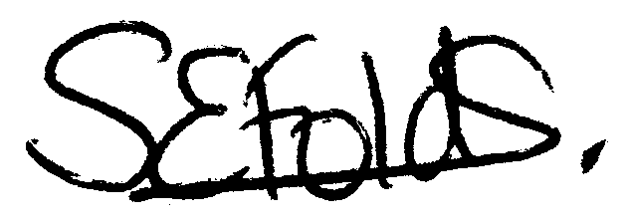

Samantha Folds
Clerk to Cury Parish Council

