CURY PARISH COUNCIL

I hereby summon you to attend an Extraordinary Meeting of Cury Parish Council to be held
at 6.00pm on Wednesday 09 October 2019 in the Cury Methodist Chapel, Cury.
The public and press are cordially invited to attend. Any plans are available to view from 5.45pm.

1. Apologies for Absence
2. Declarations of Interest – Members to declare pecuniary and non-pecuniary interests (including details thereof) in respect of any item(s) on this Agenda
3. To agree the Minutes of the Parish Council Meeting held on Wednesday 10 July 2019

4. Planning
(a) To consider and respond to any Planning Applications received
(i) PA19/07417 – Nanfan Farm, Churchtown - Continued use of land for the stationing of 8 caravans (for occasional seasonal occupation by farm workers)
(ii) PA19/08364 - Mrs West - Chez L'ouest - Without compliance of condition 4 PA18/05313 Proposed new dwelling with integrated annexe and retention of tempory caravan during the building works

(b) To receive any Planning Decisions
(i) PA19/06249 - Mr J Slade - Nanfan Farm, Churchtown - Proposed Garages - Approved

(c) To receive any further planning correspondence

5. To discuss the future of the play equipment in the park (following the site meeting)

Council to withdraw if necessary under the Public Bodies Admissions to Meetings Act 1960 Section 1, Local Government Act 1972 Section 100 Sections 2 & 3 and Local Government Act 172 Schedule 12 Section 42. Given under my hand this First day of October 2019.

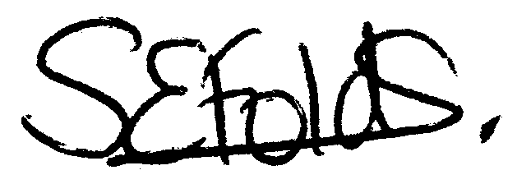

Samantha Folds - Clerk to Cury Parish Council

