CURY PARISH COUNCIL

I hereby summon you to attend a Meeting of Cury Parish Council to be held on Thursday 25 January 2024 at 7.00pm in the Cury Village Hall, Cury. The public and press are cordially invited to attend.

1. Apologies for Absence
2. Declarations of Interest – Members to declare personal and prejudicial interests (including details thereof) in respect of any item(s) on this Agenda
3. Chairman’s Comments
- To agree the Minutes of the Parish Council Meeting held on Thursday 23 November 2023
5. Matters arising from the above approved minutes which are not covered in this agenda
6. Reports
(a) To receive an update on Cury School
(b) To receive the Report from Cornwall Councillor
(c) Helston and South Kerrier Community Area Partnership
7. Planning
(a) To consider and respond to any Planning Applications received
(i) PA23/09675 – Mayfield Barn, White Cross – Proposed extension alterations and open porch
(ii) PA23/10158 - Gwenton Farm, Bochym Hill - Removal of Section 106 Agreement in relation to W2/PA99/00978/F dated 27th March 2003 Conversion and extension of redundant barn to dwelling for an agricultural worker and installation of a septic tank
(b) To receive any Planning Decisions
(i) PA23/05929 - Cury C Of E Primary School - Disused school to be refurbished as a SEN School with small extension to rear (kitchen and teaching space), roof replacement with coated metal cladding and new carpark - Approved
(c) Any correspondence received
8. Parish Matters
To consider the following:-
(a) Playing Field
(b) Highways
(c) Public Rights of Way
(d) Public Open Spaces (Cemetery, village green, etc)
(e) Emergency Plan
9. To discuss the Village Hall Costs
10. Financial Matters
(a) To receive and approve the financial report for the previous two months
(b) To receive any LGA 1972 Section 137 Requests for grant funding
(c) Other matters
11. Correspondence
12. Matters for the next Parish Council Meeting
To receive notice of items to be included on the agenda for the next Parish Council Meeting scheduled to be held on Thursday 28 March 2024 in the Cury Village Hall

Council to withdraw if necessary under the Public Bodies Admissions to Meetings Act 1960 Section 1, Local Government Act 1972 Section 100 Sections 2 & 3 and Local Government Act 172 Schedule 12 Section 42. Given under my hand this Sixteenth day of January 2024.

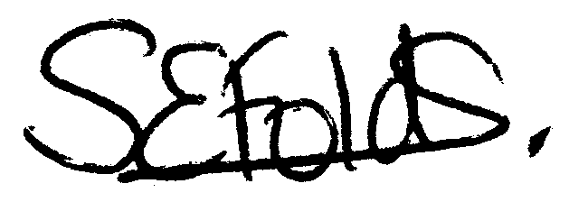

Samantha Folds
Clerk to Cury Parish Council

